KAMPALA JUNIOR ACADEMY
HOLIDAY WORK SET TWO 2020
ENGLISH
PRIMARY TWO

My name is ________________________________________________
School _____________________________________________________

1. Fill in the missing letters.
(a) un__fo__m (b) f__ag (c) bal__

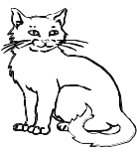
2. Name these objects
(a) ____________________
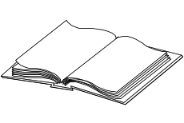
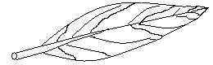
(b) ___________________ (c) __________

3. Arrange the words in a b c order.
(a) egg dog cat
___________________________________________________
(b) peas onion meat
___________________________________________________

4. Write the plural of the underlined words.
(a) Peter has a pen. __________________________________
(b) Our teacher is a good man. _______________________
(c) The dish is full of food. _________________________
5. Write in full.
(a) Tr. _____________ (c) Nov. _______________
(b) Dr. _____________

6. Arrange the letters to form correct words.
(a) skde _______________ (c) bleta ____________
(b) ircha _______________

7. Circle the compound word
(a) Our classroom is clean.
(b) The teapot is on the table.
(c) The blackboard is big.
(d) Mother’s handbag is black.

8. Underline the odd member in the list.
(a) pencil, book, rubber, car
(b) John, Peter, Jane, Charles
(c) mango, oranges, apples, posho

9. Write a small word from the big one.
(a) weather _________________ (c) teacher _________
(b) wash _______________


10. Fill in the correct word.

- Tom is pointing ___________ the aeroplane.

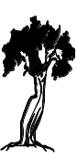

(b) The tree is _____________ the hut.

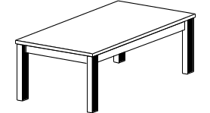
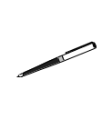
(c) The pencil is _____________ the table.

11. Fill in the correct word from the brackets.
(a) _______________ are the books. (Hear, Here)
(b) Teacher _____________ my name. (knows, nose)
(c) The man has one daughter and a ________ (sun, son)

12. Join using ‘and’
(a) Alex has a ball. Tina has a ball.
___________________________________________________
(b) Mary went to the shop. Mary bought sweets.
___________________________________________________
___________________________________________________
(c) Joan is smart. Annet is smart.
___________________________________________________

13. Use has/have
(a) I ____________ a nice skirt.
(b) She ________________ gone to the market.
(c) The boys ________________ eaten fruits.

14. Give one word for many. (utensils, furniture, domestic)
(a) Beds, chairs, tables are ____________________.
(b) Dog, sheep, pig are kept at home. They are ________________ animals.
(c) Plates, cups, saucepans are ______________.

15. Tick √ the nouns in the sentences below.
(a) I want to become a doctor.
(b) James has a good handwriting.
(c) We ate rice yesterday.
(d) Our cat is black.

16. Use ‘a’ or ‘an’
(a) Tom has _______ tomato.
(b) There is _______ orange in the basket.
(c) _____ elephant is a big animal.

17. Use the verbs in brackets correctly.
(a) I am __________________ in my book. (write)
(b) Mother ________________ food yesterday. (cook)
---END---

